Wabash Tailgate!

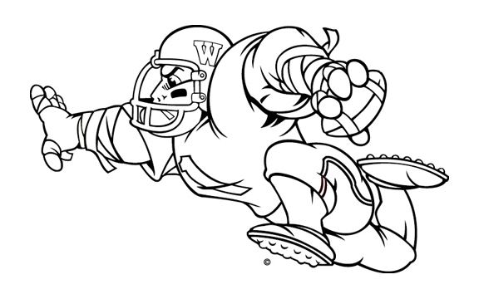
You are invited!
Join other Wabash College fans for a pre-game tailgate ‘Bash!

Wabash College
vs.

Earlham
Date: Saturday, September 30, 2006
Game time: 1:00 PM
Tailgate: starts at 11:00 AM
Directions: Enter the Earlham campus via the College Ave. and G. Street Entrance. There is a four-way stop and a concrete sign that says "Earlham College G Street Entrance." Park on the grass in the area indicated on this map. There will be someone to direct you once you arrive. For another view, go to: www.earlham.edu/map/images/campus_map.pdf

No host and no cost: Just bring something to eat and drink and join other Wabash fans as we get ready to cheer the Little Giants on to victory.

For any questions, contact Heather at bazzanih@wabash.edu or call 765-361-6360.

Tailgate Location
